Stewardship If you have already signed up to our Parish Giving Scheme (PGS), thank you. If you would like to join this scheme, please contact our treasurer Charmaine Augustus (telephone 352914), who will be happy to provide you with the necessary form/information. We now have so little take up on the boxed weekly stewardship envelopes that it is no longer viable for us to purchase them. We hope therefore that those of you who currently give via this method will feel able to change to PGS or at least will still feel that you can support us via the collection plate. We shall of course still provide gift-aid envelopes in the pews.


Prayer list: The names of those who are ill or in need of prayer will remain on the prayer list for three weeks. However, we realise that some people may need to be on for longer and, if this is the case, please speak with Carol Sharman who will be happy to arrange this.

Deadline for Operation Christmas Child Shoe Box Appeal is rapidly approaching with the actual collection taking place on Monday, 16th November. If you are unable to bring the gift boxes to church, please contact me on 07715291204 and I will pick them up from your house. Many thanks for your continued support. Tony Armstrong

Hymn
Take my life, and let it be
consecrated, Lord, to thee.
Take my moments and my days,
let them flow in ceaseless praise.

Take my voice, and let me sing
always, only, for my King.
Take my lips, and let them be
fill’d with messages from thee.

Take my will, and make it thine,
it shall be no longer mine.
Take my heart, it is thine own,
it shall be thy royal throne.

Take my love, my Lord, I pour
at thy feet its treasure-store.
Take myself, and I will be
ever, only, all for thee.

Some material included in this service is copyright: © The Archbishops' Council 2000.
© St Mary the Virgin Burton Latimer, 2011.
CCL Licence No. 480320

The Parish Church of St Mary the Virgin, Burton Latimer

Making the love of God known in our community & homes
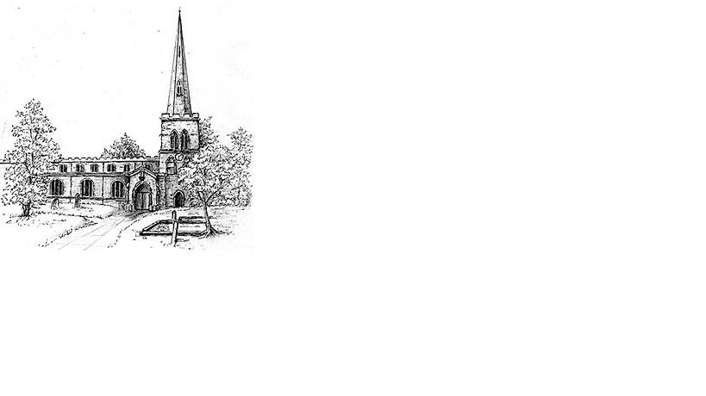
Week commencing 8th November 2020
The Third Sunday Before Advent
(Remembrance Sunday)

Our Prayer List

Each week we pray for a different street: this week is Farmfield Close

We remember those who are ill or need our prayers at this time, especially:
Sebastian, Douglas Edgar Snr, Daphne Dacre

We pray for the souls of those who have died:
Douglas Edgar Jnr, Gabriel Desroches (Simon’s father), Lynn Wesby

We remember those whose anniversaries of death are at this time:
Albert Kingsley, Michael Farrow, Olive Evans, Joan Garlick,
Doris Dilley

Contact details:

The Rector: The Revd Jez Safford, The Rectory, Preston Court, Burton Latimer, NN15 5LR. Telephone: 01536 723810.Email: jez.safford766@gmail.com.

Assistant Curate: The Revd Tom Houston, 3 Virginia Crescent, Burton Latimer, NN15 5GB. Telephone: 01536 685664. Email: houston89@hotmail.co.uk

Safeguarding Officer: Lucy Lorentzen, 3 Clipson Close, Burton Latimer,
NN15 5GH. Telephone: 07944597181. Email: lucy@lorentzen.co.uk

Website: www.stmarysburtonlatimer.co.uk or visit us on
Facebook: www.facebook.com/stmarysburtonlatimer.co.uk

Collect

Almighty Father, whose will is to restore all things in your beloved Son, the King of all: govern the hearts and minds of those in authority, and bring the families of the nations, divided and torn apart by the ravages of sin, to be subject to his just and gentle rule; who is alive and reigns with you, in the unity of the Holy Spirit, one God, now and for ever.
All Amen

First Reading

Psalm 46

¹ God is our refuge and strength,
a very present help in trouble.
² Therefore we will not fear, though the earth should change, though the mountains shake in the heart of the sea;
³ though its waters roar and foam,
though the mountains tremble with its tumult.
⁴ There is a river whose streams make glad the city of God,
the holy habitation of the Most High.
⁵ God is in the midst of the city; it shall not be moved;
God will help it when the morning dawns.
⁶ The nations are in an uproar, the kingdoms totter;
he utters his voice, the earth melts.
⁷ The Lord of hosts is with us;
the God of Jacob is our refuge.
⁸ Come, behold the works of the Lord;
see what desolations he has brought on the earth.
⁹ He makes wars cease to the end of the earth;
he breaks the bow, and shatters the spear;
he burns the shields with fire.
¹⁰ “Be still, and know that I am God,
I am exalted among the nations,
I am exalted in the earth.”
¹¹ The Lord of hosts is with us;
the God of Jacob is our refuge.

This is the Word of the Lord
All Thanks be to God

Gospel

Alleluia, alleluia. Blessed is the King who comes in the name of the Lord. Peace in heaven and glory in the highest heaven.
All Alleluia

Hear the Gospel of our Lord Jesus Christ according to N.
All Glory to you, O Lord.

Matthew 25.1-13

Jesus spoke this parable to the disciples: ¹‘The kingdom of heaven will be like this. Ten bridesmaids took their lamps and went to meet the bridegroom. ²Five of them were foolish, and five were wise. ³When the foolish took their lamps, they took no oil with them; ⁴but the wise took flasks of oil with their lamps. ⁵As the bridegroom was delayed, all of them became drowsy and slept. ⁶But at midnight there was a shout, “Look! Here is the bridegroom! Come out to meet him.” ⁷Then all those bridesmaids got up and trimmed their lamps. ⁸The foolish said to the wise, “Give us some of your oil, for our lamps are going out.” ⁹But the wise replied, “No! there will not be enough for you and for us; you had better go to the dealers and buy some for yourselves.” ¹⁰And while they went to buy it, the bridegroom came, and those who were ready went with him into the wedding banquet; and the door was shut. ¹¹Later the other bridesmaids came also, saying, “Lord, lord, open to us.” ¹²But he replied, “Truly I tell you, I do not know you.” ¹³Keep awake therefore, for you know neither the day nor the hour.’

This is the Gospel of the Lord
All Praise to you, O Christ

Prayer after Communion

God of peace, whose Son Jesus Christ proclaimed the kingdom and restored the broken to wholeness of life: look with compassion on the anguish of the world, and by your healing power make whole both people and nations; through our Lord and Saviour Jesus Christ.

