4

Prayer after Communion

God of all mercy,in this eucharist you have set aside our sinsand given us your healing:grant that we who are made whole in Christmay bring that healing to this broken world,in the name of Jesus Christ our Lord.

Hymn

Lead us, heavenly Father, lead us
o’er the world’s tempestuous seas,
guard us, guide us, keep us, feed us,
for your help is full and free,
here possessing every blessing
if our God our Father be.

Saviour, by your grace restore us,
all our weaknesses are plain,
you have lived on earth before us,
you have felt our grief and pain,
tempted, taunted, yet undaunted,
from the depths you rose again.

Spirit of our God, descending,
fill our hearts with holy peace,
love with ev’ry passion blending,
pleasure that can never cease,
thus provided, pardon’d, guided,
ever shall our joys increase.

Contact details:

The Rector: The Revd Jez Safford, The Rectory, Preston Court, Burton Latimer,

NN15 5LR. Telephone: 01536 723810.Email: jez.safford766@gmail.com.

Assistant Curate: The Revd Tom Houston, 3 Virginia Crescent, Burton Latimer,

NN15 5GB. Telephone: 01536 685664. Email: houston89@hotmail.co.uk
Safeguarding Officer: Lucy Lorentzen, 3 Clipson Close, Burton Latimer,
NN15 5GH. Telephone: 07944597181. Email: lucy@lorentzen.co.uk

Website: www.stmarysburtonlatimer.co.uk or visit us on
Facebook: www.facebook.com/stmarysburtonlatimer.co.uk

Some material included in this service is copyright: © The Archbishops' Council 2000.
© St Mary the Virgin Burton Latimer, 2011.
CCL Licence No. 480320

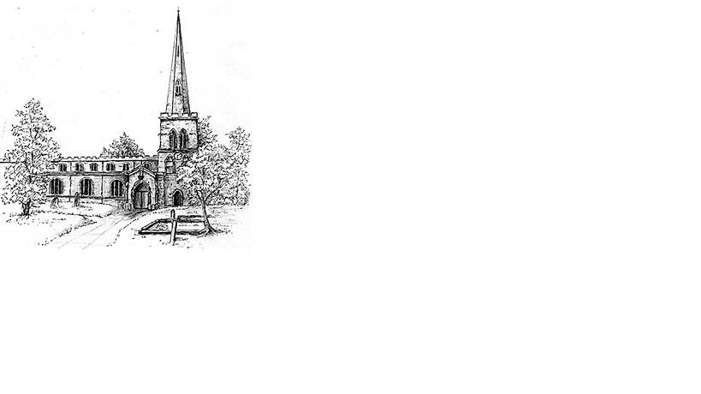
The Parish Church of St Mary the Virgin, Burton Latimer

Making the love of God known in our community & homes

Week commencing 30th August 2020
The Twelfth Sunday after Trinity

Hello, Everyone.

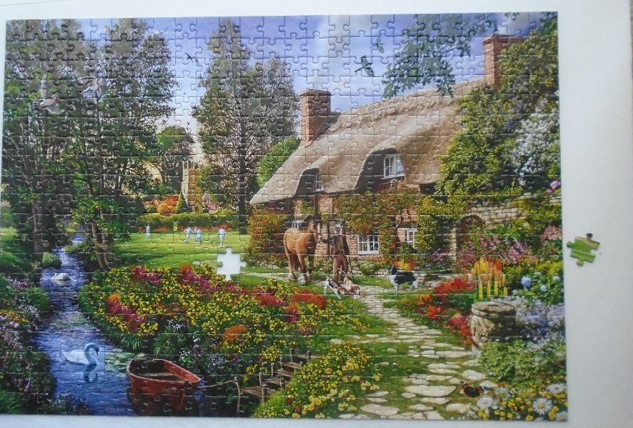
I do hope that you are all well. The blustery days and the rain this last week, has meant more time inside. My brother-in-law Dave and my friend’s husband Ian and I enjoy swapping jig-saw puzzles. The lads would usually be playing golf, so these puzzles keep their minds occupied and me from eating snacks. What do we look for in a piece from a puzzle? We look at its size, shape and colour combination and whether it is a perfect fit. Every piece has a special place. A piece may look right – size, shape etc. – but unless it is intended for that exact part of the whole picture, it will not be a perfect fit.
Every piece is needed. Every piece is individual and unique to that puzzle. It’s just not the same if a piece is missing.
St. Paul, in his letter to the church in Rome speaks of us as being members of the body of Christ. The body has many parts and each part has its own part to play : ”We have gifts that differ according to the grace given to us…” Paul says. Jesus told a number of parables about things that were lost and the joy that there was when they were found. God loves us all. Every one of us is unique and has a particular place in the big picture. If one piece is lost, it needs to be found.
In these difficult days, let us all stay firm and hold fast to what is good. Whatever our size, shape and colour combination, may we all find a perfect fit. Amen

God bless you all - Ann

Daily Psalms
Sunday, 30th August – Psalm 26.1-8
Monday, 31st August – Psalm 99
Tuesday, 1st September – Psalm 106
Wednesday 2nd September – Psalm 111
Thursday, 3rd September – Psalm 115
Friday, 4th September – Psalm 139
Saturday, 5th September – Psalm 121

2

Prayers
Holy and gracious God, we pray for others, prayers that bring to mind the world’s realities. Please teach us not to be afraid, because it is here we find you, sharing this deeply troubled world with us. Please bless all who are continuing to make a difference: scientists working faster than ever before to find cure or vaccine for covid-19; chefs, volunteers, entertainers, neighbours and countless more.
May they know your laughter and love.
We ask you to bless all who are there to care for those who are at their lowest, especially in health and care services. May they know your persevering strength.
We pray for the hundreds of thousands who are grieving here and across the world: for the loss of loved ones, loss of livelihood, loss of confidence and hope, loss of any sense of wellbeing.
May they know your comfort, strong and everlasting.
We pray for people who need the world to be a more just and equal place, and for those who have power to make changes. May it happen quickly and peacefully.
May they know your righteousness.
We pray for all who need the world to remember them: refugees and asylum seekers, all living in poverty and suffering from climate change.
May we remember; may they know your provision through us.

Thank you, Lord, for all, profoundly known and loved, who enrich our lives every day. Amen

Our Prayer List
In company with the other churches in the town, each week we pray for a different street: this week is Denton Court

We remember those who are ill or need our prayers at this time, especially:
Mick French, Jackie Kings, Sebastian, Yvonne Desroches, Sandra Bennett

We pray for the souls of those who have died:
Jim Fraser, Olive Croft

We remember those whose anniversaries of death are at this time:
Alice Dacre, Ben Holmes

Collect
Almighty and everlasting God,you are always more ready to hear than we to prayand to give more than either we desire or deserve:pour down upon us the abundance of your mercy,forgiving us those things of which our conscience is afraidand giving us those good thingswhich we are not worthy to askbut through the merits and mediationof Jesus Christ your Son our Lord,who is alive and reigns with you,in the unity of the Holy Spirit,one God, now and for ever Amen

3

First Reading

Romans 12.9-21⁹Let love be genuine; hate what is evil, hold fast to what is good; ¹⁰love one another with mutual affection; outdo one another in showing honour. ¹¹Do not lag in zeal, be ardent in spirit, serve the Lord. ¹²Rejoice in hope, be patient in suffering, persevere in prayer. ¹³Contribute to the needs of the saints; extend hospitality to strangers.
¹⁴Bless those who persecute you; bless and do not curse them. ¹⁵Rejoice with those who rejoice, weep with those who weep. ¹⁶Live in harmony with one another; do not be haughty, but associate with the lowly; do not claim to be wiser than you are. ¹⁷Do not repay anyone evil for evil, but take thought for what is noble in the sight of all. ¹⁸If it is possible, so far as it depends on you, live peaceably with all. ¹⁹Beloved, never avenge yourselves, but leave room for the wrath of God; for it is written, ‘Vengeance is mine, I will repay, says the Lord.’ ²⁰No, ‘if your enemies are hungry, feed them; if they are thirsty, give them something to drink; for by doing this you will heap burning coals on their heads.’ ²¹Do not be overcome by evil, but overcome evil with good..

This is the word of the Lord
Thanks be to God

Gospel

Hear the Gospel of our Lord Jesus Christ according to N.
Glory to you, O Lord.

Matthew 16.21-28²¹From that time on, Jesus began to show his disciples that he must go to Jerusalem and undergo great suffering at the hands of the elders and chief priests and scribes, and be killed, and on the third day be raised. ²²And Peter took him aside and began to rebuke him, saying, ‘God forbid it, Lord! This must never happen to you.’ ²³But he turned and said to Peter, ‘Get behind me, Satan! You are a stumbling-block to me; for you are setting your mind not on divine things but on human things.’
²⁴Then Jesus told his disciples, ‘If any want to become my followers, let them deny themselves and take up their cross and follow me. ²⁵For those who want to save their life will lose it, and those who lose their life for my sake will find it. ²⁶For what will it profit them if they gain the whole world but forfeit their life? Or what will they give in return for their life?
²⁷For the Son of Man is to come with his angels in the glory of his Father, and then he will repay everyone for what has been done. ²⁸Truly I tell you, there are some standing here who will not taste death before they see the Son of Man coming in his kingdom.’

This is the Gospel of the Lord
Praise to you, O Christ
Prayer after Communion overleaf ……./

