4
Prayer after Communion
Holy Father,who gathered us here around the table of your Sonto share this meal with the whole household of God:in that new world where you reveal the fullness of your peace,gather people of every race and languageto share in the eternal banquet of Jesus Christ our Lord.

Hymn
To God be the glory!
Great things He hath done,
so loved He the world that He gave us His Son,
who yielded His life an atonement for sin,
and opened the life gate that all may go in.

Praise the Lord, praise the Lord!
Let the earth hear His voice,
praise the Lord, praise the Lord!
Let the people rejoice.
O come to the Father,
through Jesus the Son,
and give Him the glory,
great things He hath done!

O perfect redemption, the purchase of blood!
To every believer the promise of God.
The vilest offender who truly believes,
that moment from Jesus a pardon receive.
Praise the Lord, praise the Lord …

Great things He hath taught us,
great things He hath done,
and great our rejoicing through Jesus the Son,
but purer, and higher, and greater will be
our wonder, our rapture, when Jesus we see.
Praise the Lord, praise the Lord …

Contact details:

The Rector: The Revd Jez Safford, The Rectory, Preston Court, Burton Latimer,

NN15 5LR. Telephone: 01536 723810.Email: jez.safford766@gmail.com.

Assistant Curate: The Revd Tom Houston, 3 Virginia Crescent, Burton Latimer,

NN15 5GB. Telephone: 01536 685664. Email: houston89@hotmail.co.uk
Safeguarding Officer: Lucy Lorentzen, 3 Clipson Close, Burton Latimer,
NN15 5GH. Telephone: 07944597181. Email: lucy@lorentzen.co.uk
Website: www.stmarysburtonlatimer.co.uk or visit us on
Facebook: www.facebook.com/stmarysburtonlatimer.co.uk
Some material included in this service is copyright: © The Archbishops' Council 2000.
© St Mary the Virgin Burton Latimer, 2011.
CCL Licence No. 480320

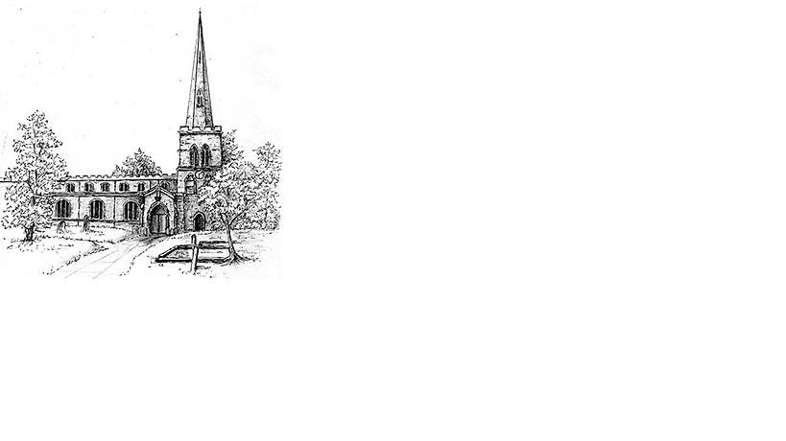
The Parish Church of St Mary the Virgin, Burton Latimer

Making the love of God known in our community & homes

Week commencing 9th August 2020
The Ninth Sunday after Trinity

Dear Friends

It seems like 'storms' are the key word of this week. In our family service (do take a look if you get a chance) we thought about the wise and foolish builders and explored what happens to both their houses when a storm comes. Then in our gospel passage we have the story of Peter walking on the water as the waves crash against the boat. It's interesting that both stories show us how storms can both destroy but also reveal things. The wise man's house, thought it took longer and more effort to build, resists the storm, whilst the 'quick and easy house' built on sand is washed away. Only through the storm are the true foundations revealed. Peter in his storm chooses not to hide and cling to the boat like the rest of the (far saner) disciples but steps out and discovers a faith that lets him walk on water.

Storms may destroy, but they also reveal things. This storm of Coronavirus has revealed many things about ourselves and society, somethings we may wish to rebury, whilst others we are keen not to lose again. Though the wind is starting to die down, we all face the question, what will my house look like when the storm ends?
Every blessing
Tom

Daily Psalms

Sunday, 9th August – Psalm 85.8-13
Monday, 10th August – Psalm 47
Tuesday, 11th August – Psalm 50
Wednesday 12th August – Psalm 59
Thursday, 13th August – Psalm 62
Friday, 14th August – Psalm 38
Saturday, 15th August – Psalm 98;138

2

Prayers

Father God, we thank you for the joy of human love, and for all those among whom we live and work. We pray particularly for those who have health concerns, worrying circumstances, or worries about life direction and for those among our friends and families who do not know you, or whose faith has been shaken. We bring before you all who suffer mental or emotional anguish and those who despair. We pray for those facing another day of pain, another day of hunger, another day of fear especially of the on-going Pandemic.

Merciful God, gather into your eternal kingdom all who have come to the end of this earthly life and rejoice to see you as you really are. We remember all whom we love but can no longer see, and thank you for your all-embracing love and undergirding faithfulness to us.

We ask these things in the name of your Son, our Saviour, Jesus Christ our Lord Amen

Our Prayer List

In company with the other churches in the town, each week we pray for a different street: this week is Croxon Close

We remember those who are ill or need our prayers at this time, especially:
Mick French, Jackie Kings, Sebastian, Yvonne Desroches,
Jean Thompson

We pray for the souls of those who have died:
Louise Dove, David Revett, Michael Guest

We remember those whose anniversaries of death are at this time:
Amy Baddeley, Mary Stokes, Gabriella Manning

Collect

Almighty God,who sent your Holy Spiritto be the life and light of your Church:open our hearts to the riches of your grace,that we may bring forth the fruit of the Spiritin love and joy and peace;through Jesus Christ your Son our Lord,who is alive and reigns with you,in the unity of the Holy Spirit,one God, now and for ever.and reigns with you,in the unity of the Holy Spirit,one God, now and for ever.
Amen

3

First Reading Romans 10.5-15

⁵Moses writes concerning the righteousness that comes from the law, that ‘the person who does these things will live by them.’ ⁶But the righteousness that comes from faith says, ‘Do not say in your heart, “Who will ascend into heaven?”’ (that is, to bring Christ down) ⁷‘or “Who will descend into the abyss?”’ (that is, to bring Christ up from the dead). ⁸But what does it say?‘The word is near you,on your lips and in your heart’(that is, the word of faith that we proclaim); ⁹because if you confess with your lips that Jesus is Lord and believe in your heart that God raised him from the dead, you will be saved. ¹⁰For one believes with the heart and so is justified, and one confesses with the mouth and so is saved. ¹¹The scripture says, ‘No one who believes in him will be put to shame.’ ¹²For there is no distinction between Jew and Greek; the same Lord is Lord of all and is generous to all who call on him. ¹³For, ‘Everyone who calls on the name of the Lord shall be saved.’¹⁴But how are they to call on one in whom they have not believed? And how are they to believe in one of whom they have never heard? And how are they to hear without someone to proclaim him? ¹⁵And how are they to proclaim him unless they are sent? As it is written, ‘How beautiful are the feet of those who bring good news!’

This is the word of the Lord
Thanks be to God

Gospel Matthew 14.22-33

Immediately after feeding the crowd with the five loaves and two fish, ²²Jesus made the disciples get into the boat and go on ahead to the other side, while he dismissed the crowds. ²³And after he had dismissed the crowds, he went up the mountain by himself to pray. When evening came, he was there alone, ²⁴but by this time the boat, battered by the waves, was far from the land, for the wind was against them. ²⁵And early in the morning he came walking towards them on the lake. ²⁶But when the disciples saw him walking on the lake, they were terrified, saying, ‘It is a ghost!’ And they cried out in fear. ²⁷But immediately Jesus spoke to them and said, ‘Take heart, it is I; do not be afraid.’²⁸Peter answered him, ‘Lord, if it is you, command me to come to you on the water.’ ²⁹He said, ‘Come.’ So Peter got out of the boat, started walking on the water, and came towards Jesus. ³⁰But when he noticed the strong wind, he became frightened, and beginning to sink, he cried out, ‘Lord, save me!’ ³¹Jesus immediately reached out his hand and caught him, saying to him, ‘You of little faith, why did you doubt?’ ³²When they got into the boat, the wind ceased. ³³And those in the boat worshipped him, saying, ‘Truly you are the Son of God.’

This is the Gospel of the Lord
Praise to you, O Christ
Prayer after Communion overleaf

