4

Prayer after Communion

God of our pilgrimage,you have led us to the living water:refresh and sustain usas we go forward on our journey,in the name of Jesus Christ our Lord.
Amen

Hymn for today
Just as I am, without one plea
but that thy blood was shed for me,
and that thou bidst me come to thee,
O Lamb of God I come.

Just as I am, though tossed about
with many a conflict, many a doubt,
fightings and fears within, without,
O Lamb of God I come.

Just as I am, thou wilt receive,
wilt welcome, pardon, cleanse, relieve,
because thy promise I believe,
O Lamb of God I come.

Just as I am, of that free love
the breadth, length, depth and height to prove,
here for a season, then above,
O Lamb of God I come.

Contact details:

The Rector: The Revd Jez Safford, The Rectory, Preston Court, Burton Latimer,

NN15 5LR. Telephone: 01536 723810.Email: jez.safford766@gmail.com.

Assistant Curate: The Revd Tom Houston, 3 Virginia Crescent, Burton Latimer,

NN15 5GB. Telephone: 01536 685664. Email: houston89@hotmail.co.uk

Safeguarding Officer: Lucy Lorentzen, 3 Clipson Close, Burton Latimer,
NN15 5GH. Telephone: 07944597181. Email: lucy@lorentzen.co.uk

Website: www.stmarysburtonlatimer.co.uk or visit us on
Facebook: www.facebook.com/stmarysburtonlatimer.co.uk
Some material included in this service is copyright: © The Archbishops' Council 2000.
© St Mary the Virgin Burton Latimer, 2011.
CCL Licence No. 480320

The Parish Church of St Mary the Virgin, Burton Latimer

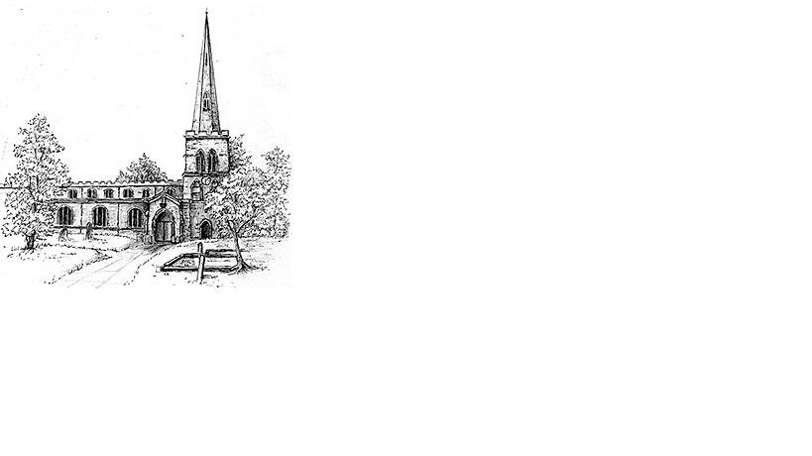
Making the love of God known in our community & homes

Week commencing 19th July 2020
The Sixth Sunday after Trinity

Welcome friends to this week’s edition of our weekly newsletter and thank you for your willingness to keep those on our prayer lists in your thoughts this week. Many of you have been asking why Yvonne is on our prayer list and we are very sorry to share that Yvonne suffered a stroke that has left her with significant challenges going forward and is currently in hospital and likely to be for while longer. I am sure you will hold Yvonne and Simon in your prayers as well as other familiar names that are going through difficult times.

It was lovely to see some of you last week in church as we are trialling how to safely offer worship for all. Your patience in signing up and being prepared to follow safety guidelines is such a blessing and so may I personally thank you for this.
This week I am taking a few days off and leave you in the very capable hands of Tom. If anyone has any concerns or decisions to make this week, remember that inviting our Lord into the process can only ever be a good thing. Even if things don’t always go to your initial plan if you do, it could often be a lot worse if you don’t…Tom taught me that ☺ A wise head on young shoulders!!
Please continue to take care and be kind to yourselves and your neighbours.

God bless you
Jez

Daily Psalms

Sunday, 19th July – Psalm 86.11-end
Monday, 20th July – Psalm 126
Tuesday, 21st July – Psalm 132
Wednesday 22nd July – Psalm 30; 32; 150
Thursday, 23rd July – Psalm 143
Friday, 24th July – Psalm 144
Saturday, 25th July – Psalm 7; 29; 117

2

Prayers
Lord our God, we rejoice that we may be called your children. In our weakness we ask you to shelter us in your hands. Strengthen us in the hope and faith that our lives will surely go the right way, not through our strength but through your protection. Grant that through your Spirit we may come to know more and more that you are with us. Help us to be alert in our daily life and to listen whenever you want to say something to us. Reveal the power and glory of your kingdom in many people, to the glory of your name, and hasten the coming on earth of all that is good and true.
Amen.

Lord God, whose Son, Jesus Christ, understood people's fear and pain before they spoke of them, we pray for those in hospital; surround the frightened with your tenderness; give strength to those in pain; hold the weak in your arms of love,
and give hope and patience to those who are recovering; we ask this through the same Jesus Christ, our Lord.
Amen

Creator God, you made us all in your image: may we discern you in all that we see,
and serve you in all that we do; through Jesus Christ our Lord.
Amen

Our Prayer List
In company with the other churches in the town, each week we pray for a different street: this week is Cranford Road

We give thanks that the operation on Charlotte’s spine went well and that Becky has safely delivered her twin girls. We thank you that Maisy Newman has returned home and is making progress, following her accident last week.

We remember those who are ill or need our prayers at this time, especially:
Ray Bunce, Mick French, Jackie Kings, Sandra Bennett, Louise Dove,
Yvonne Desroches, Joyce Lucas, Jean Thompson

We pray for the souls of those who have died:
Milly Flude

We remember those whose anniversaries of death are at this time:
Rita and Evan Beeby, Marshall Palmer, Tom Palmer, Phillip Childs, Peggy Lee

Collect
Merciful God,you have prepared for those who love yousuch good things as pass our understanding:pour into our hearts such love toward youthat we, loving you in all things and above all things,may obtain your promises,which exceed all that we can desire;through Jesus Christ our Lord.
Amen

3

First Reading

Romans 8.18-25

¹⁸I consider that the sufferings of this present time are not worth comparing with the glory about to be revealed to us. ¹⁹For the creation waits with eager longing for the revealing of the children of God; ²⁰for the creation was subjected to futility, not of its own will but by the will of the one who subjected it, in hope ²¹that the creation itself will be set free from its bondage to decay and will obtain the freedom of the glory of the children of God. ²²We know that the whole creation has been groaning in labour pains until now; ²³and not only the creation, but we ourselves, who have the first fruits of the Spirit, groan inwardly while we wait for adoption, the redemption of our bodies. ²⁴For in hope we were saved. Now hope that is seen is not hope. For who hopes for what is seen? ²⁵But if we hope for what we do not see, we wait for it with patience.

This is the word of the Lord
Thanks be to God

Gospel

Matthew 13.24-30,36-43

²⁴Jesus put before the crowd another parable: ‘The kingdom of heaven may be compared to someone who sowed good seed in his field; ²⁵but while everybody was asleep, an enemy came and sowed weeds among the wheat, and then went away. ²⁶So when the plants came up and bore grain then the weeds appeared as well. ²⁷And the slaves of the householder came and said to him, “Master, did you not sow good seed in your field? Where, then, did these weeds come from?” ²⁸He answered, “An enemy has done this.” The slaves said to him, “Then do you want us to go and gather them?” ²⁹But he replied, “No; for in gathering the weeds you would uproot the wheat along with them. ³⁰Let both of them grow together until the harvest; and at harvest time I will tell the reapers, Collect the weeds first and bind them in bundles to be burned, but gather the wheat into my barn.”’
³⁶Then Jesus left the crowds and went into the house. And his disciples approached him, saying, ‘Explain to us the parable of the weeds of the field.’ ³⁷He answered, ‘The one who sows the good seed is the Son of Man; ³⁸the field is the world, and the good seed are the children of the kingdom; the weeds are the children of the evil one, ³⁹and the enemy who sowed them is the devil; the harvest is the end of the age, and the reapers are angels. ⁴⁰Just as the weeds are collected and burned up with fire, so will it be at the end of the age. ⁴¹The Son of Man will send his angels, and they will collect out of his kingdom all causes of sin and all evildoers, ⁴²and they will throw them into the furnace of fire, where there will be weeping and gnashing of teeth. ⁴³Then the righteous will shine like the sun in the kingdom of their Father. Let anyone with ears listen!’

This is the Gospel of the Lord
Praise to you, O Christ Prayer after Communion overleaf

