4

Gospel

Alleluia, alleluia.Come, Holy Spirit, fill the hearts of your faithful peopleand kindle in them the fire of your love.
Alleluia.

John 20.19-2319 It was evening on the first day of the week, and the doors of the house where the disciples had met were locked for fear of the Jews. Jesus came and stood among them and said, ‘Peace be with you.’ ²⁰After he said this, he showed them his hands and his side. Then the disciples rejoiced when they saw the Lord. ²¹Jesus said to them again, ‘Peace be with you. As the Father has sent me, so I send you.’ ²²When he had said this, he breathed on them and said to them, ‘Receive the Holy Spirit. ²³If you forgive the sins of any, they are forgiven them; if you retain the sins of any, they are retained.’

This is the Gospel of the Lord
Praise to you, O Christ

Prayer after Communion

Faithful God,who fulfilled the promises of Easterby sending us your Holy Spiritand opening to every race and nationthe way of life eternal:open our lips by your Spirit,that every tongue may tell of your glory;through Jesus Christ our Lord.
Amen

Contact details:

The Rector: The Revd Jez Safford, The Rectory, Preston Court, Burton Latimer,

NN15 5LR. Telephone: 01536 723810.Email: jez.safford766@gmail.com.

Assistant Curate: The Revd Tom Houston, 3 Virginia Crescent, Burton Latimer,

NN15 5GB. Telephone: 01536 685664. Email: houston89@hotmail.co.uk

Pioneer Ordinand: Yvonne Desroches, 7 Hollow Wood Road, Burton Latimer, NN15 5RB. Telephone: 01536 678377/07989023206. Email: yvonnebing@hotmail.co.uk

Safeguarding Officer: Lucy Lorentzen, 3 Clipson Close, Burton Latimer,
NN15 5GH. Telephone: 07944597181. Email: lucy@lorentzen.co.uk

Website: www.stmarysburtonlatimer.co.uk or visit us on
Facebook: www.facebook.com/stmarysburtonlatimer.co.uk
Some material included in this service is copyright: © The Archbishops' Council 2000.
© St Mary the Virgin Burton Latimer, 2011.
CCL Licence No. 480320

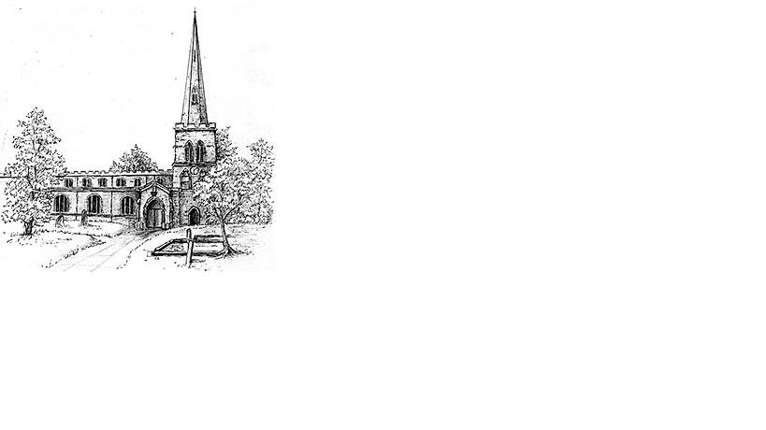
The Parish Church of St Mary the Virgin, Burton Latimer

Making the love of God known in our community & homes

Week commencing 24th May 2020
Day of Pentecost (Whit Sunday)

Dear Friends,

Today we celebrate the birthday of the church, the day God’s Holy Spirit came to live in us.

This is the day when God’s blessing broke through the boarders of Israel and spilled out onto those first converts. Through the spirit they saw a glimpse, through God’s eyes that there was no longer division through language, race or gender and most of all they were no longer enemies of God.

That story has continued for nearly 2000 years and God’s spirit has refused to be limited. The Bible has been translated into more languages than any other book. In every country, nation and continent you will find believers. When persecution, plague and natural disasters have attempted to snuff it out, the flame has become brighter.

And why shouldn’t it? When we realise what is important when we are forced to recognise we are not the centre of the universe, that we have a responsibility to our neighbours and our planet, we discover the God who has been waiting for us to wake up and come back to him. On Pentecost the first arrivals got off the plane and nothing will stop God drawing his people back to him.

So, break out your best china and drink something bubbly as we celebrate the day when it all started, when all were welcomed into God’s kingdom through Jesus Christ.

Happy Pentecost. Tom

Daily Psalms
Sunday, 31st May – Psalm 104.26-36,37b
Monday, 1st June – Psalm 113
Tuesday, 2nd June – Psalm 90,1-4,10,14-16
Wednesday, 3rd June – Psalm 123
Thursday, 4th June – Psalm 25.4-12
Friday, 5th June – Psalm 119.161-168
Saturday, 6th June – Psalm 71.7-16

2

Prayers

Almighty God, who on this day didst open the way of eternal life
to every race and nation by the promised gift of thy Holy Spirit:
Shed abroad this gift throughout the world by the preaching of the Gospel,
that it may reach to the ends of the earth; through Jesus Christ our Lord, who liveth and reigneth with thee, in the unity of the Holy Spirit, one God, for ever and ever.
Amen

For the Spirit of Peace that calms our mind and stills our life, we give you thanks. For the Spirit of Love that touches hearts and reaches out, we give you thanks. For the Spirit of Joy that lifts our soul and gives us faith, we give you thanks. For the Spirit of Power, that gift of grace for this your church, we give you thanks.
Amen

God of compassion, be close to those who are ill, afraid or in isolation.
In their loneliness, be their consolation; in their anxiety, be their hope;
in their darkness, be their light; through him who suffered alone on the cross,
but reigns with you in glory, Jesus Christ our Lord.
Amen.

Our Prayer List

In company with the other churches in the town, each week we pray for a different street: this week is Church View

We remember those who are ill or need our prayers at this time, especially: Heather, Sarah Pattison, Ian Staires, Daphne Dacre, John, Marjorie,
Henry Flynn, Graham Dayer, Emma Howe, Ray Bunce, Lilly Mannion

We pray for the souls of those who have died:
Derek Maslin, Dorothy Gibbs, Maura White, Ann Chater

We remember those whose anniversaries of death are at this time:
Harold Waller, Elizabeth Watts, Zella Aveling, Barry Marlow

3

Collect
God, who as at this timetaught the hearts of your faithful peopleby sending to them the light of your Holy Spirit:grant us by the same Spiritto have a right judgement in all thingsand evermore to rejoice in his holy comfort;through the merits of Christ Jesus our Saviour,who is alive and reigns with you,in the unity of the Holy Spirit,one God, now and for ever.
Amen

First Reading

Acts 2.1-21
¹When the day of Pentecost had come, they were all together in one place. ²And suddenly from heaven there came a sound like the rush of a violent wind, and it filled the entire house where they were sitting. ³Divided tongues, as of fire, appeared among them, and a tongue rested on each of them. ⁴All of them were filled with the Holy Spirit and began to speak in other languages, as the Spirit gave them ability.⁵Now there were devout Jews from every nation under heaven living in Jerusalem. ⁶And at this sound the crowd gathered and was bewildered, because each one heard them speaking in the native language of each. ⁷Amazed and astonished, they asked, ‘Are not all these who are speaking Galileans? ⁸And how is it that we hear, each of us, in our own native language? ⁹Parthians, Medes, Elamites, and residents of Mesopotamia, Judea and Cappadocia, Pontus and Asia, ¹⁰Phrygia and Pamphylia, Egypt and the parts of Libya belonging to Cyrene, and visitors from Rome, both Jews and proselytes, ¹¹Cretans and Arabs – in our own languages we hear them speaking about God’s deeds of power.’ ¹²All were amazed and perplexed, saying to one another, ‘What does this mean?’ ¹³But others sneered and said, ‘They are filled with new wine.’¹⁴But Peter, standing with the eleven, raised his voice and addressed them: ‘Men of Judea and all who live in Jerusalem, let this be known to you, and listen to what I say. ¹⁵Indeed, these are not drunk, as you suppose, for it is only nine o’clock in the morning. ¹⁶No, this is what was spoken through the prophet Joel: ¹⁷“In the last days it will be, God declares,that I will pour out my Spirit upon all flesh,and your sons and your daughters shall prophesy,and your young men shall see visions,and your old men shall dream dreams.¹⁸Even upon my slaves, both men and women,in those days I will pour out my Spirit;and they shall prophesy.¹⁹And I will show portents in the heaven aboveand signs on the earth below,blood, and fire, and smoky mist.²⁰The sun shall be turned to darknessand the moon to blood,before the coming of the Lord’s great and glorious day.²¹Then everyone who calls on the name of the Lord shall be saved.”
This is the word of the Lord
Thanks be to God
Gospel reading overleaf

