4

took place. ²²Moreover, some women of our group astounded us. They were at the tomb early this morning, ²³and when they did not find his body there, they came back and told us that they had indeed seen a vision of angels who said that he was alive. ²⁴Some of those who were with us went to the tomb and found it just as the women had said; but they did not see Jesus.’ ²⁵Then he said to them, ‘Oh, how foolish you are, and how slow of heart to believe all that the prophets have declared! ²⁶Was it not necessary that the Messiah should suffer these things and then enter into his glory?’ ²⁷Then beginning with Moses and all the prophets, he interpreted to them the things about himself in all the scriptures.

²⁸As they came near the village to which they were going, he walked ahead as if he were going on. ²⁹But they urged him strongly, saying, ‘Stay with us, because it is almost evening and the day is now nearly over.’ So he went in to stay with them. ³⁰When he was at the table with them, he took bread, blessed and broke it, and gave it to them. ³¹Then their eyes were opened, and they recognized Jesus; and he vanished from their sight. ³²They said to each other, ‘Were not our hearts burning within us while he was talking to us on the road, while he was opening the scriptures to us?’ ³³That same hour they got up and returned to Jerusalem; and they found the eleven and their companions gathered together. ³⁴They were saying, ‘The Lord has risen indeed, and he has appeared to Simon!’ ³⁵Then they told what had happened on the road, and how he had been made known to them in the breaking of the bread.

This is the Gospel of the Lord
Praise be to you, O Christ

Prayer after Communion
Living God,your Son made himself known to his disciplesin the breaking of bread:open the eyes of our faith,that we may see him in all his redeeming work;who is alive and reigns, now and for ever.

Contact details:

The Rector: The Revd Jez Safford, The Rectory, Preston Court, Burton Latimer,

NN15 5LR. Telephone: 01536 723810.Email: jez.safford766@gmail.com.

Assistant Curate: The Revd Tom Houston, 3 Virginia Crescent, Burton Latimer,

NN15 5GB. Telephone: 01536 685664. Email: houston89@hotmail.co.uk
Pioneer Ordinand: Yvonne Desroches, 7 Hollow Wood Road, Burton Latimer, NN15 5RB. Telephone: 01536 678377/07989023206. Email: yvonnebing@hotmail.co.uk
Safeguarding Officer: Lucy Lorentzen, 3 Clipson Close, Burton Latimer,
NN15 5GH. Telephone: 07944597181. Email: lucy@lorentzen.co.uk
Website: www.stmarysburtonlatimer.co.uk or visit us on
Facebook: www.facebook.com/stmarysburtonlatimer.co.uk

Some material included in this service is copyright: © The Archbishops' Council 2000.
© St Mary the Virgin Burton Latimer, 2011.
CCL Licence No. 480320

The Parish Church of St Mary the Virgin, Burton Latimer

Making the love of God known in our community & homes
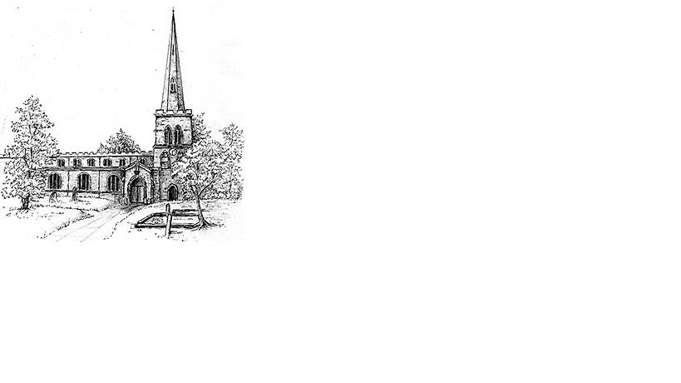

Week commencing 26th April 2020

The Third Sunday of Easter

Hello, Everyone

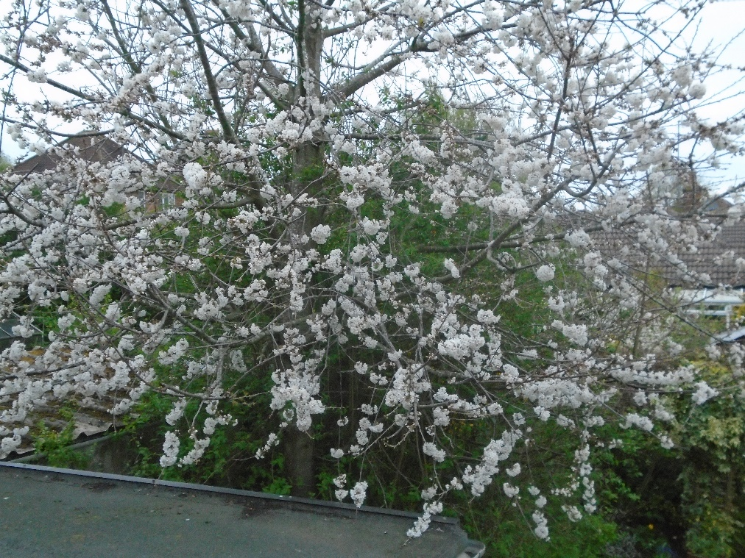
It is my turn to write something on the notice sheet. After the cold, wet and grey winter, here we are in a truly glorious Spring. The Coronavirus is keeping us indoors, but those of us lucky enough to have some garden will be appreciating God’s wonderful creation. This year I have spent more time in the garden than I have for many years.

From my bedroom window I am able to look out at an ornamental Cherry tree. It is covered with pure white blossom. It reminds me of a song that we performed a few years ago. The title was “Sakura” which means Cherry blossom in Japanese. At this time of year the people of Japan spend time with family and friends in parks and gardens under the Cherry trees. The festival is called Hanami. Of course, this year, like Easter, that will not happen.

It is difficult to cope with isolation, but we are able to give thanks and praise to God for His Creation and for new life. Please continue to stay in touch with church friends as well as family friends – thank God for technology! Stay safe and well, and do ‘phone one of us if you need to talk or need help of any sort. My love to you all, Ann

Daily Psalms
Sunday, 26th April – Psalm 116.1-3,10-end
Monday, 27th April – Psalm 96
Tuesday, 28th April – Psalm 98
Wednesday, 29th April – Psalm 105
Thursday, 30th April – Psalm 136
Friday, 1st May – Psalm 139:146
Saturday, 2nd May – Psalm 110

2

Prayers

Holy God, you have called us to follow in the way of your risen Son, and to care for those who are our companions, not only with words of comfort, but with acts of love. Seeking to be true friends of all, we offer our prayers on behalf of the church and the world. You made the world in beauty, and restore all things in glory through the victory of Jesus Christ. We pray that, wherever your image is still disfigured by poverty, sickness, selfishness, war and greed, the new creation in Jesus Christ may appear in justice, love, and peace, to the glory of your name.
Amen

Keep us, good Lord, under the shadow of your mercy in this time of uncertainty and distress. Sustain and support the anxious and fearful, and lift up all who are brought low; that we may rejoice in your comfort knowing that nothing can separate us from your love in Christ Jesus our Lord.
Amen.

Heavenly Father, we bring before you all those people working on the front line at this difficult time. We think of the NHS workers, police, armed forces, prison offers, postmen, refuse collectors, those working in schools and those working to keep us fed. We give You thanks for them and the work that they are doing. Each day they put themselves at risk for the sake of us all and we ask You to be with them and keep them safe.
Amen

Our Prayer List

In company with the other churches in the town, each week we pray for a different street: this week is Cadwell Close

We remember those who are ill or need our prayers at this time, especially: Heather, Carter Lewis, Sarah Pattison, Ian Staires, Daphne Dacre, Henry Flynn, Graham Dayer, Helen, Amy, Emma Howe, Gabe Desroches

We pray for the souls of those who have died:
Jackie Drury, Jamie Bellamy, Clayton Thomas, Aldo Delli-Gatti

We remember those whose anniversaries of death are at this time:
Charles Shaw, Bryan Betts, Arthur Mutlow, Ralph Aveling, Basil Wood, Betty Peck, Roger Safford

3

Collect
Almighty Father,who in your great mercy gladdened the discipleswith the sight of the risen Lord:give us such knowledge of his presence with us,that we may be strengthened and sustained by his risen lifeand serve you continually in righteousness and truth;through Jesus Christ your Son our Lord,who is alive and reigns with you,in the unity of the Holy Spirit,one God, now and for ever.
Amen

First Reading

1 Peter 1.17-23
¹⁷If you invoke as Father the one who judges all people impartially according to their deeds, live in reverent fear during the time of your exile. ¹⁸You know that you were ransomed from the futile ways inherited from your ancestors, not with perishable things like silver or gold, ¹⁹but with the precious blood of Christ, like that of a lamb without defect or blemish. ²⁰He was destined before the foundation of the world, but was revealed at the end of the ages for your sake. ²¹Through him you have come to trust in God, who raised him from the dead and gave him glory, so that your faith and hope are set on God.

²²Now that you have purified your souls by your obedience to the truth so that you have genuine mutual love, love one another deeply from the heart. ²³You have been born anew, not of perishable but of imperishable seed, through the living and enduring word of God.

This is the word of the Lord
Thanks be to God

Gospel

Luke 24.13-35
¹³On that same day, two of the disciples were going to a village called Emmaus, about seven miles from Jerusalem, ¹⁴and talking with each other about all these things that had happened. ¹⁵While they were talking and discussing, Jesus himself came near and went with them, ¹⁶but their eyes were kept from recognizing him. ¹⁷And he said to them, ‘What are you discussing with each other while you walk along?’ They stood still, looking sad. ¹⁸Then one of them, whose name was Cleopas, answered him, ‘Are you the only stranger in Jerusalem who does not know the things that have taken place there in these days?’ ¹⁹Jesus asked them, ‘What things?’ They replied, ‘The things about Jesus of Nazareth, who was a prophet mighty in deed and word before God and all the people, ²⁰and how our chief priests and leaders handed him over to be condemned to death and crucified him. ²¹But we had hoped that he was the one to redeem Israel. Yes, and besides all this, it is now the third day since these things

Continued overleaf…./

