4

²⁴But Thomas (who was called the Twin), one of the twelve, was not with them when Jesus came. ²⁵So the other disciples told him, ‘We have seen the Lord.’ But he said to them, ‘Unless I see the mark of the nails in his hands, and put my finger in the mark of the nails and my hand in his side, I will not believe.’
²⁶A week later his disciples were again in the house, and Thomas was with them. Although the doors were shut, Jesus came and stood among them and said, ‘Peace be with you.’ ²⁷Then he said to Thomas, ‘Put your finger here and see my hands. Reach out your hand and put it in my side. Do not doubt but believe.’ ²⁸Thomas answered him, ‘My Lord and my God!’ ²⁹Jesus said to him, ‘Have you believed because you have seen me? Blessed are those who have not seen and yet have come to believe.’
³⁰Now Jesus did many other signs in the presence of his disciples, which are not written in this book. ³¹But these are written so that you may come to believe that Jesus is the Messiah, the Son of God, and that through believing you may have life in his name.

This is the word of the Lord Thanks be to God

Daily Psalms

Sunday, 19th April – Psalm 16
Monday, 20th April – Psalm 2.1-9
Tuesday, 21st April – Psalm 93
Wednesday, 22nd April – Psalm 34.1-8
Thursday, 23rd April – Psalm 126
Friday, 24th April – Psalm 27.1-5,16-17
Saturday, 25th April – Psalm 119.9-16

Contact details:

The Rector: The Revd Jez Safford, The Rectory, Preston Court, Burton Latimer,

NN15 5LR. Telephone: 01536 723810.Email: jez.safford766@gmail.com.

Assistant Curate: The Revd Tom Houston, 3 Virginia Crescent, Burton Latimer,

NN15 5GB. Telephone: 01536 685664. Email: houston89@hotmail.co.uk
Pioneer Ordinand: Yvonne Desroches, 7 Hollow Wood Road, Burton Latimer, NN15 5RB. Telephone: 01536 678377/07989023206. Email: yvonnebing@hotmail.co.uk
Safeguarding Officer: Lucy Lorentzen, 3 Clipson Close, Burton Latimer,
NN15 5GH. Telephone: 07944597181. Email: lucy@lorentzen.co.uk
Website: www.stmarysburtonlatimer.co.uk or visit us on
Facebook: www.facebook.com/stmarysburtonlatimer.co.uk

Some material included in this service is copyright: © The Archbishops' Council 2000.
© St Mary the Virgin Burton Latimer, 2011.
CCL Licence No. 480320

The Parish Church of St Mary the Virgin, Burton Latimer

Making the love of God known in our community & homes
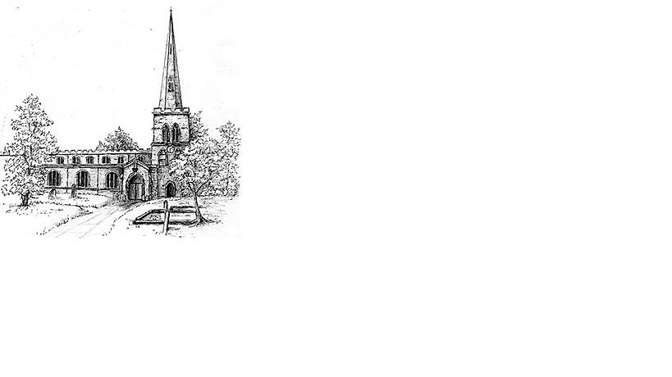

Week commencing 19th April 2020

The Second Sunday of Easter

Dear friends

I don’t know where you would have gone on holiday this Easter, but I should have been in North Devon, sitting on a beach. As is normally the case with vicars, I was going to disappear as soon as the plates and fizz had been packed away on Easter Sunday. Of course, with the lockdown this didn’t happen and so, like many of you we were forced, to ‘holiday’ in the same place we have been stuck in for the last four weeks.

Normality is certainly on hold and the dates in our diaries that normally give us time and energy to face the next event have all but disappeared or lost their usual meaning. And yet like many of our biblical heroes who have gone through unsettling times, it is when we too are in unsettled times that their stories reveal their depth.

Because, rather than sitting on a beach, enjoying their time with the newly resurrected Jesus and having a well-deserved break after the rollercoaster of emotions that first holy week, the disciples entered an even stranger time of uncertainty. Instead of rest, they must come to terms with what it means to see Jesus alive, popping up and challenging their understanding of normality. They must learn what it means to live as resurrected beings in a world that still contains death. Or as Jez said so movingly last week, to be Easter Sunday people in a Good Friday world.

Sadly it looks like this period of abnormality will need to continue for many more weeks, maybe months and yet I pray that just as Easter was not the end for the disciples story, so these next few weeks will be as life changing in your quiet times with God. Though normality is on hold, I pray that those moments where Jesus enters in will be just as special, if not more so. Keep safe and Happy Easter.
Tom

2

Our Prayer List

O God, your Son remained with his disciples after his resurrection, teaching them to love all people as neighbours. As his disciples in this age, we offer our prayers on behalf of this world in which we are privileged to live and our neighbours with whom we share it.
In company with the other churches in the town, each week we pray for a different street: this week is Bunting Close

We remember those who are ill or need our prayers at this time, especially: Heather, Carter Lewis, Sarah Pattison, Ian Staires, Daphne Dacre, Henry Flynn, Graham Dayer, Helen, Amy, Emma Howe

We pray for the souls of those who have died:
Jackie Drury, Jamie Bellamy

We remember those whose anniversaries of death are at this time:
Eileen Pitt, Evelyn Linnell

Prayers

Creator of the universe, you made the world in beauty, and restore all things in glory through the victory of Jesus Christ. We pray that, wherever your image is still disfigured by poverty, sickness, selfishness, war and greed,
the new creation in Jesus Christ may appear in justice, love, and peace,
to the glory of your name. Amen.
Amen

God of love and hope, you made the world and care for all creation, but the world feels strange right now. The news is full of stories about Coronavirus. Some people are worried that they might get ill. Others are anxious for their family and friends. Be with them and help them to find peace. We pray for the doctors and nurses and scientists, and all who are working to discover the right medicines to help those who are ill. Thank you that even in these anxious times, you are with us. Help us to put our trust in you and keep us safe
Amen.

Blessed are you, O God of our Lord Jesus Christ, in whom we receive the legacy of a living hope, born again not only from his death but also from his resurrection. May we who have received forgiveness of sins through the Holy Spirit live to set others free, until, at length, we enter the inheritance that is imperishable and unfading,
where Christ lives and reigns with you and the same Spirit.
Amen.
3

Collect
Almighty Father,you have given your only Son to die for our sinsand to rise again for our justification:grant us so to put away the leaven of malice and wickednessthat we may always serve youin pureness of living and truth;through the merits of your Son Jesus Christ our Lord,who is alive and reigns with you,in the unity of the Holy Spirit,one God, now and for ever.
Amen

First Reading Acts 2.14a,22-32

On the day of Pentecost, ¹⁴Peter, standing with the eleven, raised his voice and addressed the crowd: ²²‘You that are Israelites, listen to what I have to say: Jesus of Nazareth, a man attested to you by God with deeds of power, wonders, and signs that God did through him among you, as you yourselves
know – ²³this man, handed over to you according to the definite plan and foreknowledge of God, you crucified and killed by the hands of those outside the law. ²⁴But God raised him up, having freed him from death, because it was impossible for him to be held in its power. ²⁵For David says concerning him, “I saw the Lord always before me,for he is at my right hand so that I will not be shaken;²⁶therefore my heart was glad, and my tongue rejoiced;moreover, my flesh will live in hope.²⁷For you will not abandon my soul to Hades,or let your Holy One experience corruption.²⁸You have made known to me the ways of life;you will make me full of gladness with your presence.”²⁹‘Fellow Israelites, I may say to you confidently of our ancestor David that he both died and was buried, and his tomb is with us to this day. ³⁰Since he was a prophet, he knew that God had sworn with an oath to him that he would put one of his descendants on his throne. ³¹Foreseeing this, David spoke of the resurrection of the Messiah, saying, “He was not abandoned to Hades,nor did his flesh experience corruption.”³²This Jesus God raised up, and of that all of us are witnesses.’

Gospel John 20.19-31

¹⁹When it was evening on the first day of the week, and the doors of the house where the disciples had met were locked for fear of the Jews, Jesus came and stood among them and said, ‘Peace be with you.’ ²⁰After he said this, he showed them his hands and his side. Then the disciples rejoiced when they saw the Lord. ²¹Jesus said to them again, ‘Peace be with you. As the Father has sent me, so I send you.’ ²²When he had said this, he breathed on them and said to them, ‘Receive the Holy Spirit. ²³If you forgive the sins of any, they are forgiven them; if you retain the sins of any, they are retained.’

Continued overleaf…./

