4

Hymn for Palm Sunday

Theodulph of Orleans, ca. 760–821
2.The company of angels
Are praising thee on high,
And mortal men and all things
Created make reply.
The people of the Hebrews
With palms before thee went;
Our praise and love and anthems
Before thee we present.
1.All glory, laud, and honour
To thee, Redeemer, King,
To whom the lips of children
Made sweet hosannas ring.
Thou art the King of Israel,
Thou David's royal Son,
Whog in the Lord's name comest,
The King and Blessed One.
3.To thee, before thy passion,
They sang their hymns of praise;
To thee, now high exalted,
Our melody we raise.
Thou didst accept their praises;
Accept the love we bring,
Who in all good delightest,
Thou good and gracious King

Contact details:

The Rector: The Revd Jez Safford, The Rectory, Preston Court, Burton Latimer,

NN15 5LR. Telephone: 01536 723810.Email: jez.safford766@gmail.com.

Assistant Curate: The Revd Tom Houston, 3 Virginia Crescent, Burton Latimer,

NN15 5GB. Telephone: 01536 685664. Email: houston89@hotmail.co.uk
Pioneer Ordinand: Yvonne Desroches, 7 Hollow Wood Road, Burton Latimer, NN15 5RB. Telephone: 01536 678377/07989023206. Email: yvonnebing@hotmail.co.uk
Safeguarding Officer: Lucy Lorentzen, 3 Clipson Close, Burton Latimer,
NN15 5GH. Telephone: 07944597181. Email: lucy@lorentzen.co.uk

Website: www.stmarysburtonlatimer.co.uk or visit us on
Facebook: www.facebook.com/stmarysburtonlatimer.co.uk

Some material included in this service is copyright: © The Archbishops' Council 2000.
© St Mary the Virgin Burton Latimer, 2011.
CCL Licence No. 480320

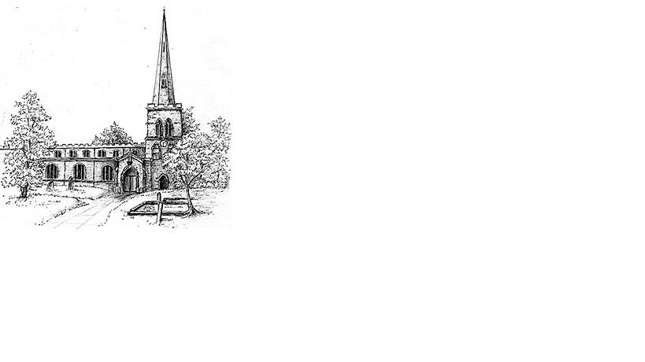
The Parish Church of St Mary the Virgin, Burton Latimer

Making the love of God known in our community & homes

Week commencing 5th April 2020
Palm Sunday

Dear friends,

So here we are at Palm Sunday and walking into Holy Week in very unfamiliar territory. I’m guessing like me and all of us in the ministry team and ministers all over the world, this is the first Easter celebration behind closed doors….or is it?
That very first Easter the disciples and followers of Jesus were locked away for fear of their lives. Many Christians persecuted for their faith over the centuries have had to worship behind closed doors. I wonder if the gift of this troublesome time is that we can begin to truly identify with the persecuted church and to discover what is most important in our life; that despite the violence caused by this virus we have absolute peace and certainty that we are loved by God.

Through Jesus’ statement of intent by entering into Jerusalem on that first Palm Sunday, we can know and experience the love He has for us by His walking towards the cross, rather than running away from it. The necessity to isolate cannot isolate us from our Father in Heaven, His Son our Lord, because His Holy Spirit binds us together with our brothers and sisters all over the world who are also worshipping God sheltering from the virus.

Every blessing….Jez

PS if we find ourselves bemoaning that we are behind our doors this Palm Sunday, praise God we have doors and walls to hide behind, many are not so blessed. Look forward to our time together on Sunday and Wednesday. x

Daily Psalms

Sunday, 5th April – Psalm 31.9-16
Monday, 6th April – Psalm 41
Tuesday, 7th April – Psalm 27
Wednesday, 8th April – Psalm 102.1-18
Thursday, 9th April – Psalm 42;43
Friday, 10th April – Psalm 69
Saturday, 11th April – Psalm 142

2
Prayers


Merciful God, as we enter Holy week, turn our hearts again to Jerusalem, and to the life, death, and resurrection of Jesus Christ. Stir up within us the gift of faith that we may not only praise him with our lips, but may follow him in the way of the cross.
Amen

Keep us, good Lord, under the shadow of your mercy in this time of uncertainty and distress. Sustain and support the anxious and fearful, and lift up all who are brought low; that we may rejoice in your comfort knowing that nothing can separate us from your love in Christ Jesus our Lord.
Amen.

We pray to the Lord, who is our refuge and stronghold.
For the health and well-being of our nation, that all who are fearful and anxious may be at peace and free from worry:
For the isolated and housebound, that we may be alert to their needs, and care for them in their vulnerability:
For our homes and families, our young people, and all in any kind of need or distress:
For a blessing on our local community, that our neighbourhoods may be places of trust and friendship, where all are known and cared for:
We commend ourselves, and all for whom we pray, to the mercy and protection of God.
Amen.

Our Prayer List

In company with the other churches in the town, each week we pray for a different street: this week is Brooks Close

We remember those who are ill or need our prayers at this time, especially:
Heather, Carter Lewis, Sarah Pattison, Ian Staires, Daphne Dacre

We pray for the souls of those who have died:
Margaret Phillips

We remember those whose anniversaries of death are at this time:

3
Collect
Almighty and everlasting God,who in your tender love towards the human racesent your Son our Saviour Jesus Christto take upon him our fleshand to suffer death upon the cross:grant that we may follow the example of his patience and humility,and also be made partakers of his resurrection;through Jesus Christ your Son our Lord,who is alive and reigns with you,in the unity of the Holy Spirit,one God, now and for ever.
Amen

First Reading
Philippians 2.5-11
⁵Let the same mind be in you that was in Christ Jesus,⁶who, though he was in the form of God,did not regard equality with Godas something to be exploited,⁷but emptied himself,taking the form of a slave,being born in human likeness.And being found in human form,⁸he humbled himselfand became obedient to the point of death – even death on a cross.
⁹Therefore God also highly exalted himand gave him the namethat is above every name,¹⁰so that at the name of Jesusevery knee should bend,in heaven and on earth and under the earth,¹¹and every tongue should confessthat Jesus Christ is Lord,to the glory of God the Father.

This is the word of the Lord
Thanks be to God

Gospel
Matthew 21.1-11
¹When they had come near Jerusalem and had reached Bethphage, at the Mount of Olives, Jesus sent two disciples, ²saying to them, ‘Go into the village ahead of you, and immediately you will find a donkey tied, and a colt with her; untie them and bring them to me. ³If anyone says anything to you, just say this, “The Lord needs them.” And he will send them immediately.’ ⁴This took place to fulfil what had been spoken through the prophet, saying, ⁵‘Tell the daughter of Zion,Look, your king is coming to you,humble, and mounted on a donkey,and on a colt, the foal of a donkey.’⁶The disciples went and did as Jesus had directed them; ⁷they brought the donkey and the colt, and put their cloaks on them, and he sat on them. ⁸A very large crowd spread their cloaks on the road, and others cut branches from the trees and spread them on the road. ⁹The crowds that went ahead of him and that followed were shouting, ‘Hosanna to the Son of David!Blessed is the one who comes in the name of the Lord!Hosanna in the highest heaven!’¹⁰When he entered Jerusalem, the whole city was in turmoil, asking, ‘Who is this?’ ¹¹The crowds were saying, ‘This is the prophet Jesus from Nazareth in Galilee.’

Prayer after Communion
Lord Jesus Christ,you humbled yourself in taking the form of a servant,and in obedience died on the cross for our salvation:give us the mind to follow youand to proclaim you as Lord and King,to the glory of God the Father.Amen

